1 |  | The following describes the preparation of methylamine hydrochloride, CH₃NH₃Cl from ethanamide, CH₃CONH₂. The equations involving the chemicals in the preparation are as shown:
 |  | CH₃CONH₂ + 4NaOH + Br₂ → CH₃NH₂ + Na₂CO₃ + 2NaBr + 2H₂O ……[1]
 |  | CH₃NH₂ + HCl → CH₃NH₃Cl ………….. [2]
 |  | The procedure in the preparation of methylamine, CH₃NH₂ is as follows:
 | 1. | Dissolve 36g of sodium hydroxide, NaOH in 160 cm³ water contained in a 500 cm³ conical flask and chilled the stirred solution to 0-5⁰C in ice water.
 | 2. | Add 10.8 cm³ (32.4g) of bromine to the stirred solution.
 | 3. | Add 12g ethanamide, CH₃CONH₂ to the stirred bromite(I) solution.
 | 4. | Remove the conical flask containing the alkaline solution from the ice water and set it aside at room temperature for 30 minutes.
(a) |  | What is the purpose of using ice water?
 |  | To prevent volatile bromine from vapourising or prevent side reactions
 |  | [1]
(b) |  | What apparatus are used to measure out
 | (i) | 36g NaOH - weighing balance  160 cm³ - measuring cylinder  10.8 cm³ - burette
 | (ii)
 | (iii)
 |  | [3]
(c) |  | The boiling point of CH₃NH₂ is 70⁰ – 80⁰ C. Draw the apparatus to collect CH₃NH₂ from the reaction mixture.    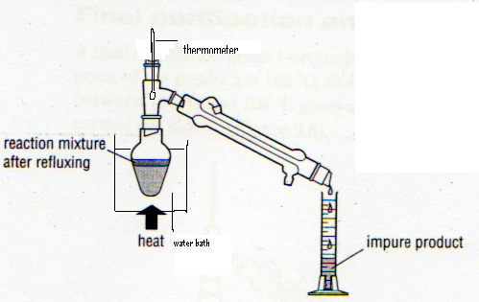
 |  | [4]
(d) |  | The last stage of reaction is to obtain colourless crystals of CH₃NH₃⁺Cl⁻. The procedure is as follows:
 | 1. | CH₃NH₂ is absorbed by hydrochloric acid in a beaker.
 | 2. | Transfer the resultant solution to a small evaporating dish and evaporate to dryness on a boiling water bath to obtain the crude dry solid.
 | (i) | Why is water bath used instead of direct heating?
 |  | CH₃NH₃⁺Cl⁻ might decompose over the Bunsen flame
 | (ii) | The crude dry solid from d(2) consists of CH₃NH₃⁺Cl⁻ with small amount of NH₄Cl. Suggest how you could purify CH₃NH₃⁺Cl⁻.
Transfer CH₃NH₃⁺Cl⁻ with NH₄Cl to a round bottom flask fitted with a condenser.
Add about 60-70 cm³ of absolute alcohol( NH₄Cl is insoluble).
Boil the mixture for 5 min.
Pour hot supernatant liquid quickly through a small fluted filter paper into a conical flask.
When cool, collect the crystals.
 |  | [4]
 |  | [Total: 12]

2 |  | Many interhalogen compounds are very active oxidising agents as well as strong acids. Examples are oxoacids of chlorine, chloric(V) acid, HClO₃ and chloric(VII) acid, HClO₄.
(a) | (i) | With an aid of an equation, show HClO₃ as a strong Bronsted-Lowry monoprotic acid in an aqueous solution.
 |  | HClO₃ + H₂O → H₃O⁺ + ClO₃⁻
 | (ii) | Explain why chloric(VII) is a stronger acid than chloric(V) acid in terms of their structures and bonding.
 |  | ClO₄⁻ more stable as negative charge is more dispersed as extent of delocalisation of π electrons is greater. Hence chloric(VII) is a stronger acid.
 | (iii) | Draw the dot-cross diagram of HClO₃. Using VSEPR model, predict the shape with respect to Cl and indicate a possible O-Cl-O bond angle.
 |  | 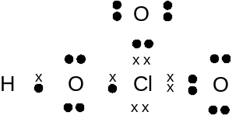
 |  | Shape – trigonal pyramidal ; bond angle - 107⁰
 |  | [6]
 |  | Labels on HClO₃ and HClO₄ accidentally dropped off. To identify them, a technician measures 1.268g if each of the acids and an adequate solution of a green aqueous iron(II) sulfate solution is added until it turns yellow. To the resulting solution, 30 cm³ of 0.500 mol dm⁻³ of AgNO₃(aq) is needed for a white precipitate to form. This white precipitate dissolves in excess aqueous ammonia.
(b) | (i) | Identify the white precipitate.
 |  | AgCl
 | (ii) | Write an equation, including state symbols to show the solubility of white precipitate in excess aqueous ammonia.
 |  | AgCl(s) + 2NH₃(aq) → Ag(NH₃)⁺Cl⁻ (aq)
 | (iii) | Identify the ion in the yellow solution and explain why it is coloured.
 |  | Fe(H₂O)₆³⁺ .
 |  | The partially filled 3d orbitals of Fe³⁺ are split into 2 different energy levels. An electron from lower energy level absorbs visible light and gets promoted to the higher energy level. The complementary colour is seen and hence complex appears coloured.
 | (iv) | Identify which of the chloric compounds gave the above result.
No of moles of Cl⁻ = no of moles of Ag⁺ = 30 X 0.5/1000 = 0.015 mol
No of moles of HClO₃ =1.268/84.5 = 0.015 mol
No fo moels of HClO₄ = 1.268/100.5 = 0.0126 mol
No of moles Cl⁻ = no of moles of HClO₃ = 0.015 mol
Hence compound is HClO₃
 |  | [10]
 |  | [Total: 16]
3 |  | Consider an equilibrium mixture,
 |  | 4NH₃(g) + 3O₂(g) 2N₂(g) + 6H₂O(g) ΔH = −1267kJmol⁻¹
The graph below shows how the fraction of N₂(g) in the equilibrium mixture varies with temperature and pressure.

Fraction of N₂ in equilibrium mixture

P₁

P₂
temperature

(a) | (i) | Comment on the shape of the curve.
 |  | As temperature increases, amount of N₂ decreases. Therefore the equilibrium position has shifted to the left since ΔH is exothermic.
 | (ii) | On the same graph, sketch a curve to show how the fraction of N₂ changes at a higher pressure, P₂ .
 |  | [3]
(b) |  | An initial 5 moles of NH₃ and 3 moles of O₂ are mixed in a 2 dm³ vessel. At 450⁰C, an equilibrium mixture shows 80% of ammonia has reacted. Calculate a value for the equilibrium constant, K_{c} and give its unit.
(0.5/2)² (1.5/2)⁶
K_{c} = (4/2)⁴ (2.25/2)³

= 4.88 X 10⁻⁴ mol dm⁻³

 |  | [3]
(c) |  | Hydrogen gas is used in the industry to convert N₂ into ammonia for the use in fertilizers. One method of preparing H₂ is to pass a mixture of carbon monoxide and steam over a Cu/Zn catalyst.
 |  | CO(g) + H₂O(g) CO₂(g) + H₂(g) ΔH = −41kJmol⁻¹
 | (i) | Use the given ΔH and bond energies values from the data booklet, calculate the bond energy in the CO molecule.
 |  | ΔH(CO) = –2(460) –41+ 2(740) + 436 = 955 kJmol⁻¹
 | (ii) | With the aid of the Boltzman-maxwell distribution curve, explain how Cu/Zn affects the rate of the above reaction.
Fraction of particles with energy
Area under curve with
Ecat > Euncat

energy
_{Ecat Euncat}
Catalyst provides an alternative route with a lower activation energy. Hence more reactants have energy greater than activation energy as shown by bigger area. Hence effective collisions increase and rate increases.
 |  | [5]
 |  | [Total: 11]
4 |  | T, an oxide of phosphorus is made up of 43.7% by mass of Phosphours.
(a) |  | Deduce the empirical empirical formula and hence the molecular formula given the molar mass of T is 288 gmol⁻.
 | P | O
% by mass | 43.7 | 56.3
No of moles | 1.410 | 3.519
Ratio | 1.00 | 2.50
 | 2 | 5

(31 X 2 + 16 X 5)n = 288
n = 2
molecular formula P₄O₁₀

 |  | [2]
(b) |  | Compare the melting point of T to that of Al₂O₃.
T which is P₄O₁₀ has molecular structure with molecules held by weak Van der Waals forces easily overcomed by small amount of energy.
Al₂O₃ has giant ionic structure with oppositely charged ions held by strong ionic bonds which require large amount of energy to overcome.
Hence T has a low melting point.
 |  | [3]
(c) |  | Al₂O₃ is amphoteric while T is acidic.  Using appropriate reagents, write balanced equations to show their properties.
 |  | Al₂O₃ + 6H⁺ → 2Al³⁺ + 3H₂O
 |  | Al₂O₃ + 2OH─ + 3H₂O → 2Al(OH)₄─
 |  | P₄O₁₀ + 12OH─ → 4PO₄^{3─} + 6H₂O
 |  | [3]
(d) |  | Describe reactions of Na₂O and T when added to water separately with appropriate equations. State the pH of the aqueous solutions formed.
Na₂O dissolves in water readily to form a strong alkaline solution with pH=13.
Na₂O + H₂O → 2NaOH
T, P₄O₁₀ dissolves in water to form a strong acid solution with pH = 2.
P₄O₁₀ + 6 H₂O → 4H₃PO₄
 |  | [4]
 |  | [Total: 12]
5 |  | The reaction scheme below illustrates the synthesis of 1,6-diamminohexane and paracetamol from phenol.
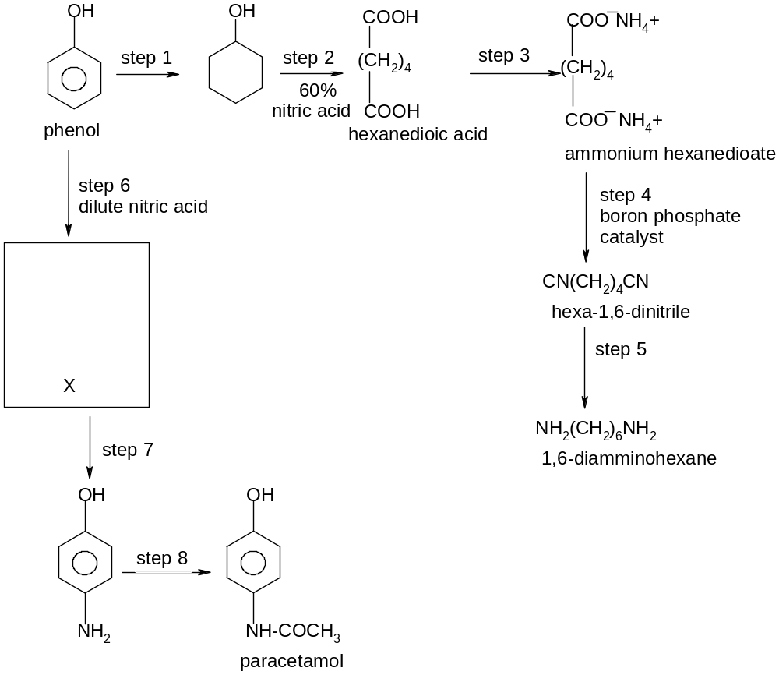
X

(a) |  | Draw the displayed formula of X formed in step 6 in the box provided.
O─H

N O
║
O

 |  | [2]
(b) |  | Suggest reagents and conditions for steps 1,3,5 and 8.
1 – H₂/ Ni, high temperature and pressure
3 – aqueous ammonia
5 – LiAlH₄/dry ether or hydrogen/Ni
8 – CH₃COCl, at room temperature
 |  | [4]
(c) |  | Name the types of reactions in steps 2,4 and 6.
Step
2 – oxidation
4 – dehydration or elimination
6 – electrophilic substitution

 |  | [3]
(d) |  | What is unusual about the reaction in step 8?
 |  | Phenol can also react with CH₃COCl to form ester.
 |  | [1]
 |  | [Total: 10]
6 |  | A cyclic compound, Y is shown below.
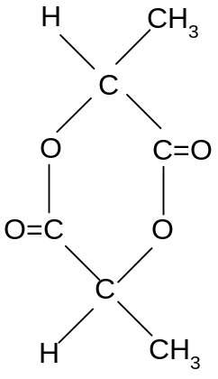

(a) |  | State the functional group in Y
 |  | Ester.
 |  | [1]
(b) |  | Compound Y is warmed with dilute sulphuric acid.
 | (i) | State the type of reaction Y undergoes.
 |  | Hydrolysis.
 | (ii) | What is the structural formula of the product labelled as Z, of molecular mass 90 formed in reaction b(i)?
COOH
│
Z : H─C─CH₃
│
OH
 |  | [2]
(c) |  | Draw the structures of the organic products formed when Z is
 | (i) | warmed with alkaline iodine.
CHI₃ , ─O─C─C─O─
║ ║
O O
 | (ii) | Reacted with phosphorus pentachloride.
COCl
│
H─C─CH₃
│
Cl

 | (iii) | Added to aqueous sodium carbonate.
COO─Na⁺
│
H─C─CH₃
│
OH

 |  | [4]
 | (iv) | Write equations for reactions (c)(ii) and (c)(iii).
COOH COCl
│ │
H─C─CH₃ + 2PCl₅ → 2POCl₃ + 2HCl + H─C─CH₃
│ │
OH Cl

COOH COO─Na⁺
│ │
2H─C─CH₃ + Na₂CO₃ → CO₂ + H₂O + 2 H─C─CH₃
│ │
OH OH

 |  | [2]
(d) |  | Is Z soluble in water? Give a reason for your answer.
 |  | Y is soluble in water due to the formation of hydrogen bonding with water molecules.
 |  | [2]
 |  | [Total: 11]

End of Paper

